# CHAPTER III METHODOLOGY

This chapter will discuss about the preparation of the Ocake: Online Cake Ordering and Delivery System. The research methodology and method were explained to further justify the data gathered along with the system’s structural models to expand the presentation and understanding of the development of the website.

**Development Method**

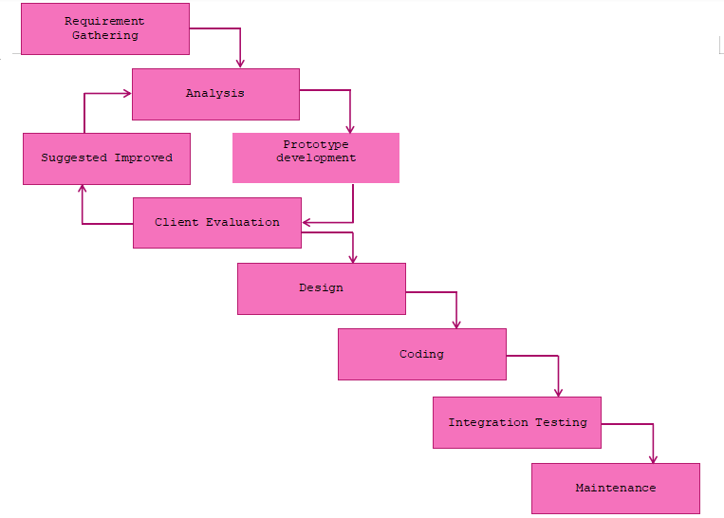

**Figure 2. Evolutionary Prototyping Model**

1. **Requirement Gathering**

The researchers gathered information to meet the user’s satisfaction on developing the website through a series of interviews with the client and some potential users. They first prepared a request letter and sent it to the client. Upon approval, the proponents and the client discussed the requirements such as flow of their business, their operation time, minimum count of customers per day, available delivery and payment method and common problems they encountered.

1. **Analysis**

The researchers looked at what needed to be done in the period allotted and discovered appropriate functionalities and tools for creating the Ocake: Online Cake Ordering and Delivery System's website such as the menu where customers can choose from, an admin module for the update of transactions, as well as the color theme needed for the system.

1. **Prototype Development**

The researchers made a prototype for the website development to make the functionality more reliable and effective and to improve the things that should be done accordingly to user satisfaction, so that the clients could visualize and become familiar with the system flows. The researchers also identified what are the other functionalities to be added and should be applied to the website.

1. **Suggested Improved**

In this phase, the researchers will work on the recommendations of the client and instructors on the documentation and system.

1. **Client Evaluation**

In this phase, the researchers will give a visit to the client and present the project and its features for them to evaluate it according to their satisfaction and needs for every transaction while using the system. This includes the design of the website such as the theme of the website and the logo used.

1. **Design**

The researchers will finalize the design suggested by the client and planned for a better user interface for the website development of the Ocake: Online Cake Ordering and Delivery System.

1. **Coding**

After making the designs for the system, the researchers will proceed to coding. This is where they will implement coding of front-end using HTML, JavaScript as well as bootstraps and back-end using PHP and (using CodeIgniter 4 Framework) to build and create the major parts and functionalities of the website. They will first built an admin module for the data management, followed by the user module to create transactions. On the other hand, the proponents will use MySQL database to store information needed by the website.

1. **Integration Testing**

At this stage, the researchers will integrate the website and test its features and functions. It will be uploaded online to test its overall functionality. The researchers chose Hostinger for web hosting and deployed the website to the World Wide Web. The researcher once again, will show how to use the website by presenting it to the client and other staff. After that, it will be deployed to Kelly's Bakeshop by allowing the client to manage the admin module

1. **Maintenance**

The last stage is maintenance. In this phase, the researchers will maintain and support the function and performance of the system. During the implementation period, the researchers will provide technical support. These include fixing errors encountered by the system during implementation such as unresponsive navigation, database error and unfit logo size to ensure that the system is working properly and operating continuously.

**Gantt Chart**

Figure 3 shows the chronological events that the website underwent. The development of the project is in line with the Gantt chart to better execute every plan upon developing the said website.

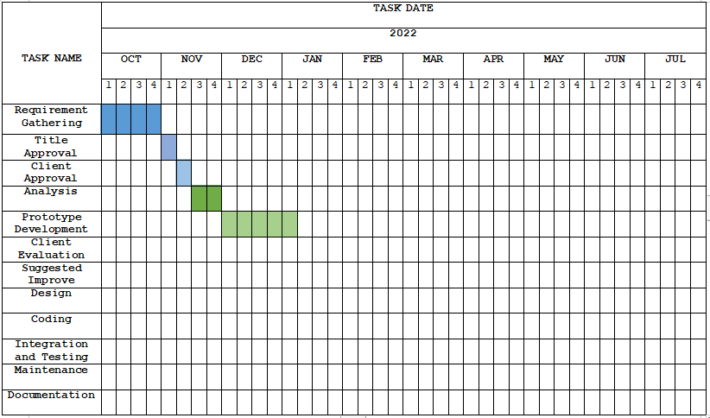

# Figure 3. Gantt Chart

**Requirements Specification**

To maximize the use of the proposed project, the users must be knowledgeable and properly oriented to the system. This includes the software interface, software requirements and the functional requirements.

**Functional Requirements**

Functional requirements pertain to the process and function of the system. This includes how the system should work form its administrator down to the end-users of the website.

**User Interface**

Ocake: Online Cake Ordering and Delivery System Website was built with an aesthetic design by using web-designing frameworks to let the users interact freely with the website. The interface and its functions are well structured to make the user interface and user experience more engaging to the user’s eyes.

**Hardware Interface**

The hardware used in this project meets the specified requirement to successfully run the system. The relation between software and hardware should always be considered for it works side by side to let the developed system run in its optimal state. The website runs in computer and 1 GB Random Access Memory or at least 1 GB RAM. This also runs indifferent brand and version of android smart phone with internet connection.

**Software Interface**

This project provides a software that is user- friendly to the admin of this system. It ensures simplicity and good navigation across the whole website. This project is developed to be used easily by its user. This interface is crucial for the success of the project for it presents the relation and operations between the system itself to its fellow components such as database and operating system. The researchers used Windows 10 operating system, Microsoft Edge as its web browser, Visual Studio Code 1.74.2 as the IDE of the system, WAMP server to create database, Codeigniter 4 PHP Framework to assists researchers by providing the simplest way to use modular methods.

**Security Interface**

The system is protected with password to prevent unauthorized activities that may be done by unauthorized users. This ensures that the system will not be put in jeopardy through attacks from hackers that will cost a lot for the system and its users. The system also enabled all available security modules of Codeigniter 4 PHP Framework.

**Technical Background**

Technical background presents the needed requirements to successfully execute the website’s development. It provides the technicalities of the project. Below consists of the hardware and software specifications that the researchers utilized.

**Hardware Specification**

A laptop was one of the most crucial pieces of hardware used as a foundation for developing. A portable laptop with an Intel Core CPU, 1.60 GHz processor speed, 2.00 GB installed RAM, a 64-bit operating system, and a 64x-based processor was used.

**Table 1. Component’s Specifications**

|  |  |  |  |
| --- | --- | --- | --- |
| **QTY** | **UNIT** | **ITEM** | **SPECIFICATIONS** |
| 1 | pc | ASUS Laptop | 15-inch; 12GB RAM; 500 HDD |
| 1 | pc | ACER Laptop | 15-inch; 4GB RAM; 128HDD |

**Software Specification**

**Table 2. Software Specifications**

|  |  |  |
| --- | --- | --- |
| **Software** | **Specifications** | |
| **Minimum** | **Recommended** |
| Operating System | Windows 7 Ultimate 64-bit | Windows 10 64-bit |
| WAMP Server | WAMP version 64 bits (x64) 3.2.6 | WAMP version 64 bits (x64) 3.2.6 |
| Visual Studio Code | Visual Studio Code version 1.74.2 | Visual Studio Code version 1.74.2 |

Table 2 shows the specifications of the software used for this study. The researchers used the most recent operating system and versions of the mentioned above for optimal use and performance of production.

**System Analysis and Design**

The project design presents the system overview and architecture.

**System Overview**

It is a system that enables people to browse and buy different cakes from the online store. The project is a list of cake items that are organized into several categories. These objects can be browsed by the user based on categories. The consumer has the option to add a product to his shopping basket if he likes it. Even cash on delivery or a check are options for payment. The user receives a copy of the shopping receipt at his email address after completing a successful purchase. The user also has the opportunity to purchase personalized cakes based on their preferences for the cake's flavor, size, form, and other factors. Thus, the online cake purchasing project makes it simple for both buyers and sellers by bringing a whole cake shop online. A computerized system that enables users to order cakes online is known as a cake ordering system. Bakeries can utilize this technique to take consumer orders. Customers can use the system to follow their orders and receive notifications on how their orders are progressing. An ordering system for cakes has the advantages of higher productivity and pleased customers. Customers can place orders and check the status of their orders online with the use of a cake ordering system. Additionally, this method can assist bakers in better managing their inventory and running their operations.

The creation of an effective database structure and a user-friendly interface are two difficulties encountered when developing a cake ordering system. It's crucial to design a user-friendly interface so that users can operate the system with ease. An effective database structure must be created to ensure that the system can handle large numbers of orders.

Overall, cake ordering systems are advantageous to bakers as well as customers. They contribute to increased consumer satisfaction and corporate efficiency. The creation of an effective database structure and building a user-friendly interface are significant obstacles that must be addressed. The cake ordering system will be a success if these issues are effectively resolved.

**System Architecture**

Figure 4 shows the system architecture of the Ocake: Online Cake Ordering and Delivery System. The user should register in order to access all the features and functions of the Online Cake Ordering and Delivery Website.

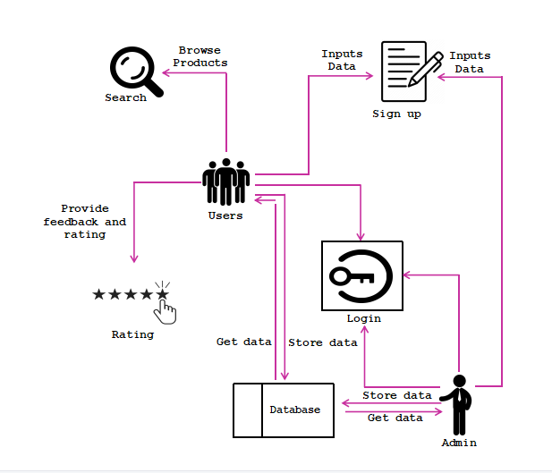This part of research display the detailed structure about the flow of the system function, and the execution of tasks to progress successfully.

# Figure 4. Ocake: Online Cake Ordering and Delivery System

**Use Case Diagram**

Figure 5 below shows the tasks of the administrator where the whole management of the system takes place.

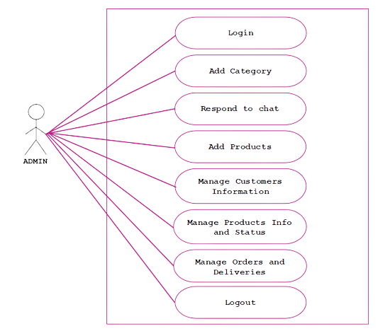

**Figure 5. Use Case of the Administrator**

Figure 6 below shows the features that a user can do in the Ocake: Online Cake Ordering and Delivery System Website.

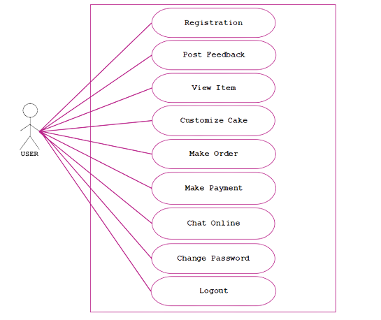**Figure 6. Use Case of the User**

**Activity Diagram**

Figure 7 shows the activity diagram of the User side. The intended activities of the users are presented below.

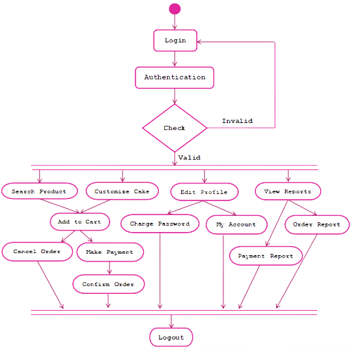

**Figure 7. Activity Diagram for User**

Figure 8 shows the activity diagram of the Administrator side. The intended activities of the admin are presented below.

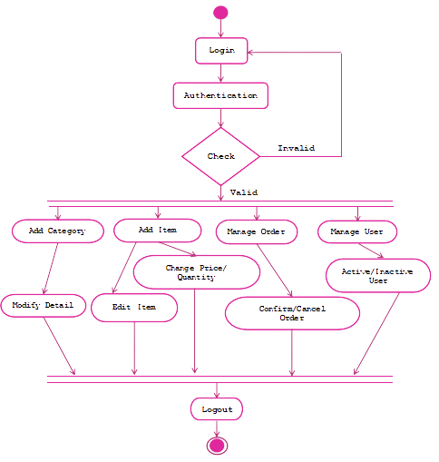

**Figure 8. Activity Diagram for Administrator**

**Flow Diagram (DFD)**

Researchers looked at the existing system's manual processes and created a data flow diagram to evaluate and compare them. An E-COMMERCE WEBSITE SYSTEM data flow diagram is used to illustrate the movement of information throughout the system. E-commerce data flow diagrams show how the information will be processed throughout the project. In this case, the DFD Levels serve as illustrations. The data flow diagram for an online store is defined by the input, processing, and output stages. A data flow diagram will reveal the pathways taken by information as it travels from one process to another within an application.

# Context Diagram

# 1111111111122222222-removebg-previewFigure 9 shows the diagram of the proposed website. In the part of users side known as customers will save their information they provided and the sales of product will be shown while in administrator side the data of profit, orders and sales report will be display. Both sides of the customers and administrator website will function accordingly to its responsibility shown in the diagram.

# Figure 9. Context Diagram of the Proposed System

**Diagram 0**

Figure 10 shows the data flow diagram for Ocake: Online Cake Ordering and Delivery System. There are four main processes, namely manage customer information, manage orders, schedule deliveries and manage transactions/payments. The first process starts when customers enter their data and the admin manage the customer information. Second, the customer is permitted to proceed to the second process of ordering a product, in which the customer can select from the categories and products available in the system or customize his desired cake and the admin manage the customer orders. Confirmation of the order status occurs in the second process, in which the customer has to wait for the order status from the administrator. The third process is that schedule delivery of the order, in which the customer has to wait for their orders. The fourth process is that the payment of the order occurs when the customer settles the payment amount for the order product that has been made.

# 111111111111-removebg-preview

# Figure 10. Data Flow Diagram of the Proposed System